EXPT NO:5 | DEVELOP INTERACTIVE DASHBOARDS FOR DYNAMIC DATA EXPLORATION USING TABLEAU AND POWERBI
DATE: 24.07.2026

PRE-LAB QUESTIONS (PROVIDE BRIEF ANSWERS TO THE FOLLOWING QUESTIONS)
- What is dynamic data exploration in BI tools, and why is it important?
Dynamic data exploration is the ability to interact with live data , filtering, drilling, sorting, and re-parameterising a view in real time , instead of reading a fixed, pre-rendered chart. It matters because different stakeholders have different questions about the same dataset; a dashboard built for dynamic exploration lets each of them self-serve an answer (e.g., "how did the South region do in Q2") without asking an analyst to build a new report, which shortens the time between a question and a decision.

- What are slicers and filters, and how do they enhance dashboard interactivity?

A filter restricts which rows of data feed a view , it can act at the data-source, worksheet/visual, or dashboard level (e.g., only show Technology orders). A slicer (Power BI's term) or quick filter (Tableau's term) is that same filtering logic exposed as an on-screen, clickable control such as a dropdown, list, or date-range slider. Because slicers are visible and interactive, end users can change what they are seeing themselves, so one dashboard effectively behaves like dozens of pre-built reports.

- How do Tableau and Power BI support drill-down and drill-through features?

Tableau supports drill-down through field hierarchies (for example the built-in Year > Quarter > Month > Day hierarchy created automatically from a date field, or a manual Category > Sub-Category hierarchy) , clicking the plus/minus icon on an axis expands or collapses one level. Power BI supports the same idea with the drill up/down arrows on the visual's toolbar, and additionally offers drill-through pages: a separate report page that a user jumps to by right-clicking a data point, landing on a page that is automatically filtered to that exact context (e.g., right-click a region to open a "Region Detail" page filtered to it).

- What is the role of parameters in creating interactive dashboards?

A parameter is a single, user-controlled input value (chosen from a dropdown, slider, or typed field) that calculations elsewhere in the workbook can reference. Parameters let one visual do the job of several , for example, a parameter that switches a chart's measure between Sales and Profit, or one that lets a user type a threshold that drives a dynamic reference line , without duplicating the chart for every possible option.

- Name some advanced interactivity features in Tableau and Power BI.

Tableau: filter/highlight/URL/set actions, dynamic zone visibility, parameter actions, and dashboard extensions. Power BI: bookmarks with buttons for guided navigation, drill-through pages, field parameters (letting users swap which measure or dimension a chart uses), report-page tooltips, and Q&A / Copilot natural-language query visuals.

IN-LAB EXERCISE:
OBJECTIVE:
To design and develop interactive dashboards in Tableau and Power BI for dynamic data exploration, enabling users to analyze, filter, and drill down into data for deeper insights.
GitHub Repo Link: https://github.com/j-abhishek26/24ADC001-24BAD002/tree/main/Experiment%205

PROCEDURE:
- Data Collection:
  - Import datasets from sources such as Excel, CSV, SQL Server, or online APIs.
  - Dataset: Retail Sales Dataset with fields such as Order Date, Region, Product Category, Sales, Profit, Quantity.
- Data Preparation and Transformation:
  - Ensure proper date formats for time-based analysis.
  - Handle missing or incorrect values.
  - Create calculated fields (e.g., Profit Margin %, Sales Growth %, Year-to-Date Sales).
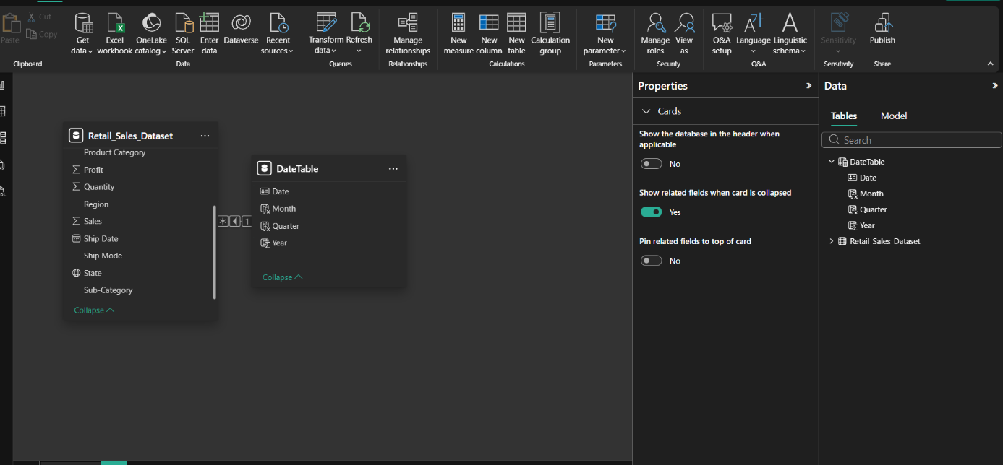
- Data Aggregation and Hierarchies:
  - Create hierarchies (e.g., Year → Quarter → Month → Day).
  - Aggregate data by region, product category, or customer segment.
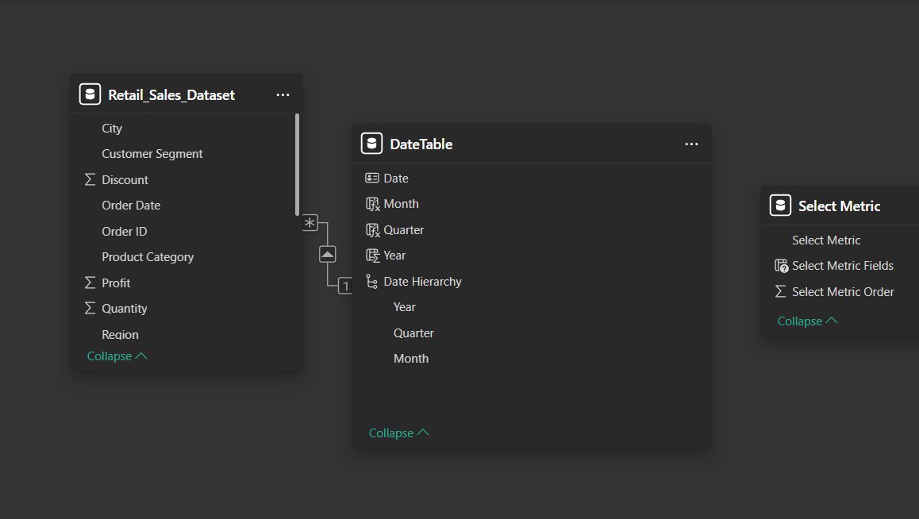
- Designing Interactive Elements:
  - Filters & Slicers: Allow filtering by product category, date range, or region.
  - Parameters: Let users switch between KPIs (e.g., Sales vs. Profit).
  - Drill-down: Enable users to explore data from summary to detail.
  - Tooltips: Add contextual details when hovering over data points.
- Dashboard Development:
  - Tableau: Use interactive filters, parameter controls, and highlight actions.
  - Power BI: Use slicers, bookmarks, and drill-through pages.
  - Add KPI cards for key metrics like Total Sales, Total Profit, Top Selling Product.
  - Use maps for regional sales analysis, line charts for trends, and bar charts for category comparisons.
- Testing Interactivity:
  - Ensure slicers and filters update all relevant visuals dynamically.
  - Test drill-down and drill-through functionality for accuracy.
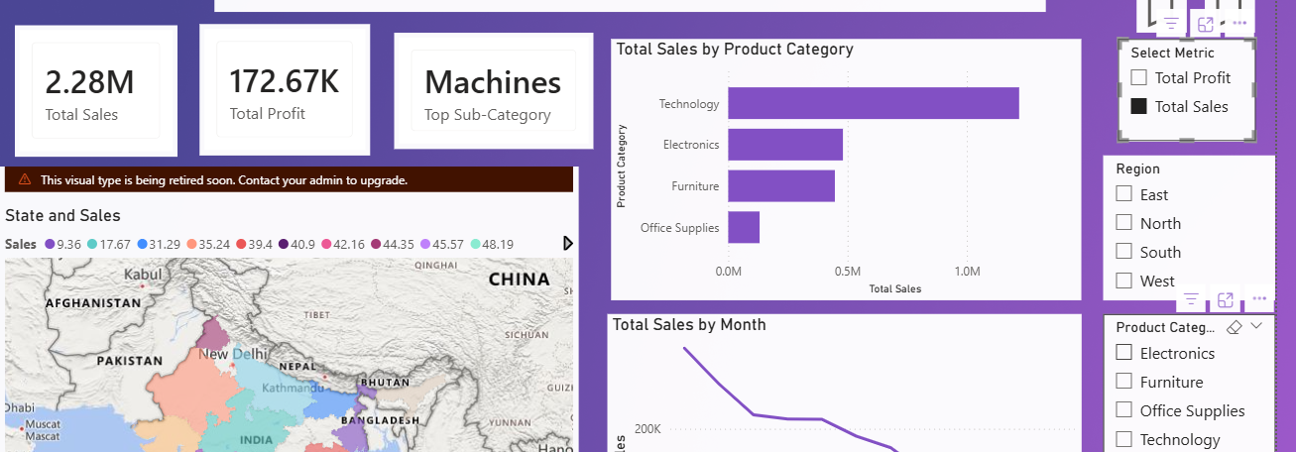

- Publishing and Sharing:
  - Tableau: Publish on Tableau Public or Tableau Server.
  - Power BI: Publish to Power BI Service and share via workspace access or public link.
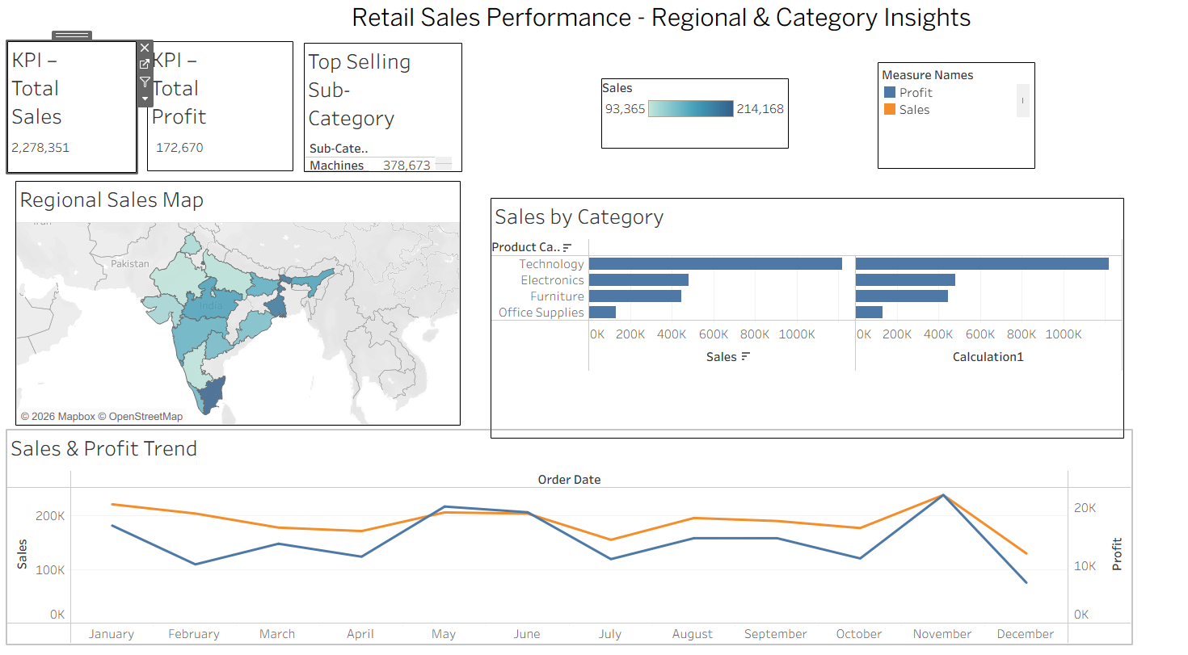
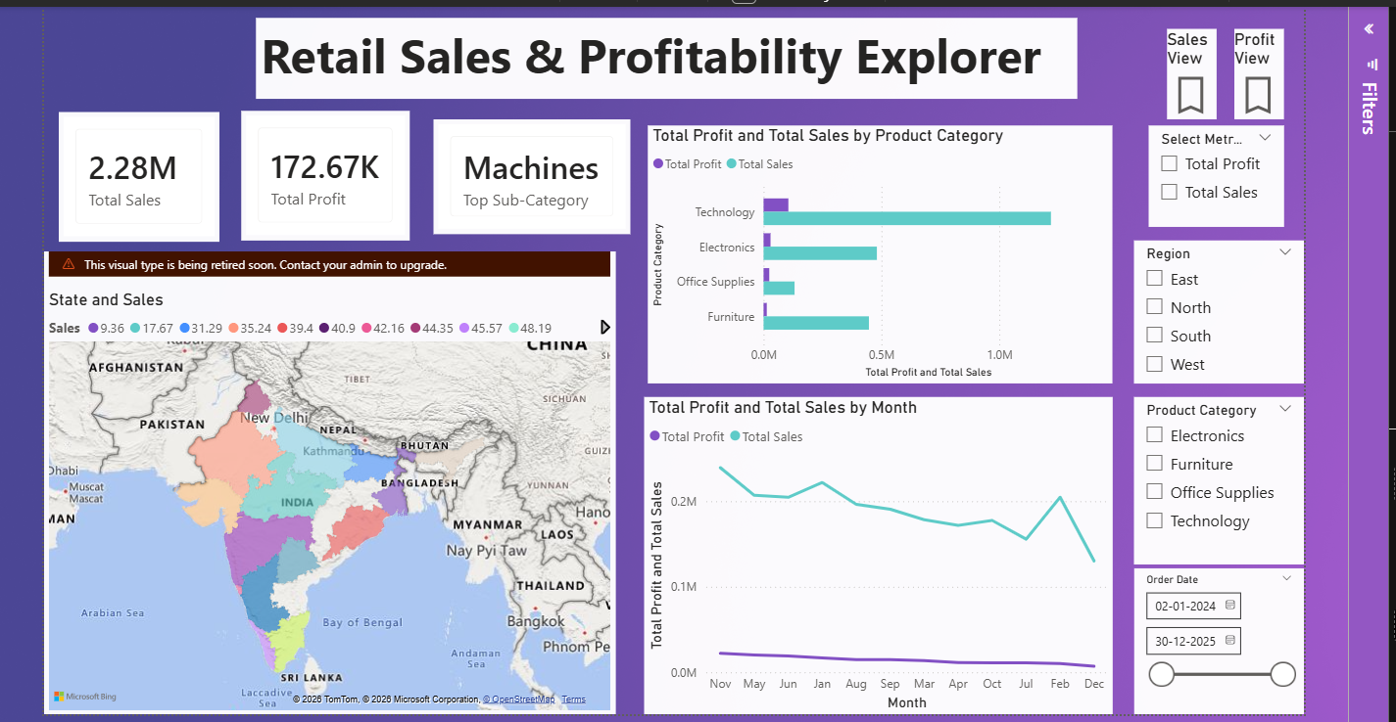
Experiment Dataset:
Retail Sales Dataset
Fields Used:
- Order Date – Date of the order
- Region – Sales region
- Product Category – Category of product sold
- Sales – Sales revenue
- Profit – Net profit from the order
- Quantity – Units sold

POST-LAB QUESTIONS (PROVIDE BRIEF ANSWERS TO THE FOLLOWING QUESTIONS)
- How did interactivity improve the analysis experience in your dashboard?

Static Sales-by-Category and map charts on their own only answer one question each. Once the Region and Category filters/slicers were connected across every visual, the same dashboard could answer "how is the South doing in Electronics" or "which state drove the Q3 dip" in a couple of clicks, without re-building a chart for every combination. That turned a fixed report into a tool for open-ended exploration.

- Which interactive feature (filters, drill-down, parameters, etc.) was most useful and why?
The date hierarchy drill-down (Year > Quarter > Month) was the most useful single feature, because a two-year trend line is too coarse to spot short dips on its own, but a fully month-by-month chart is too busy by default. Being able to start at the yearly view and drill in only where something looked interesting kept the dashboard readable while still allowing detailed investigation on demand.
- What challenges did you face while implementing drill-down or dynamic filters?

In Tableau, the year-over-year Sales Growth % table calculation initially computed along the wrong dimension until Compute Using was explicitly set to Order Date (Year); the default direction gave nonsensical percentages. In Power BI, SAMEPERIODLASTYEAR() would not evaluate correctly against the raw Order Date column in the fact table , it only worked once a dedicated DateTable was built and marked as an official date table with a proper relationship, which is a step that is easy to skip as a beginner.
- How do tooltips contribute to better dashboard storytelling?

Tooltips let a chart stay visually simple (just a bar or a map shape) while still surfacing the supporting numbers , Profit Margin %, exact Sales, Region , only when someone hovers to ask for them. That keeps the main view from being cluttered with labels, but nothing important is actually hidden; the detail is one hover away rather than being permanently displayed or permanently missing.

- What additional features would you add to make the dashboard more insightful?

A trend-line/forecast overlay on the Sales & Profit chart to project the next quarter, a threshold-based alert on Profit Margin % dropping below a set value, row-level security so each regional manager only sees their own region by default, and a natural-language Q&A box (Tableau Ask Data / Power BI Q&A) so non-technical stakeholders could type a question instead of navigating filters manually.

RESULT:
The retail sales dataset was successfully transformed, aggregated, and visualized into interactive dashboards in Tableau and Power BI. Filters, slicers, drill-downs, and parameters enabled dynamic exploration of sales and profit trends by region, product category, and time period. The resulting dashboards allowed for quick insights and deeper analysis, enhancing decision-making capabilities.

ASSESSMENT

Description | Max Marks | Marks Awarded
Pre Lab Exercise | 5
In Lab Exercise | 10
Post Lab Exercise | 5
Viva | 10
Total | 30
Faculty Signature

